# CS 255 System Design Document Template

## UML Diagrams

### UML Use Case Diagram

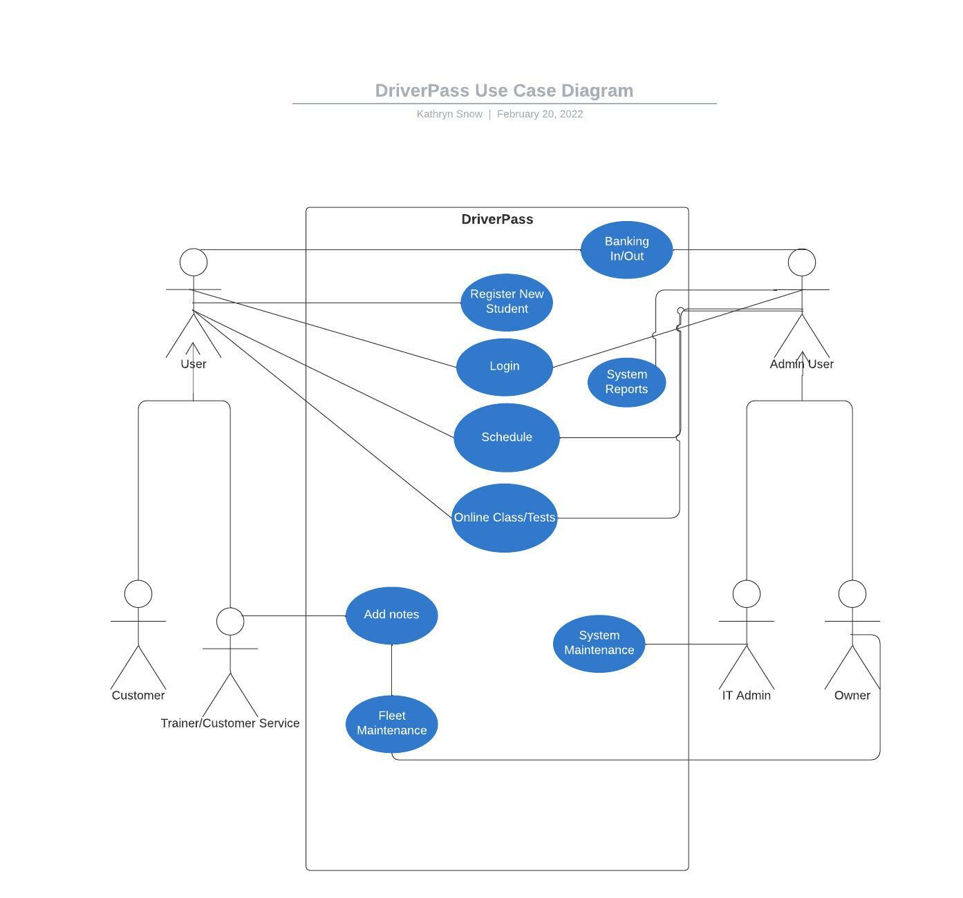

### UML Activity Diagrams

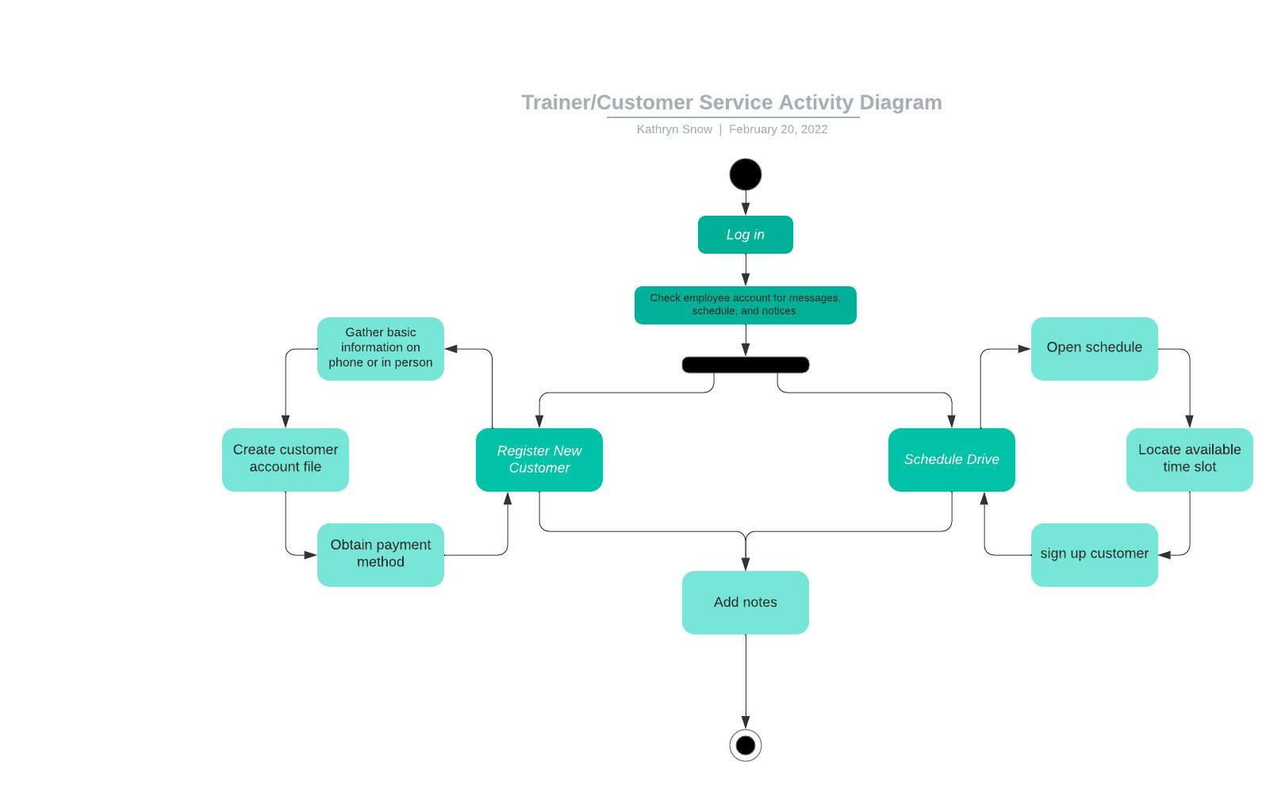

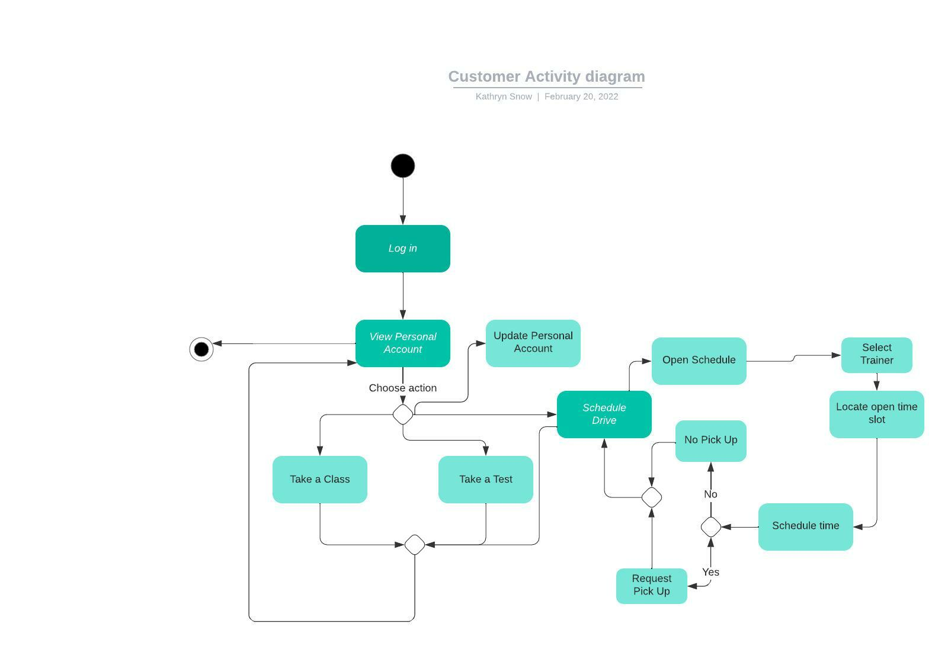

### UML Sequence Diagram

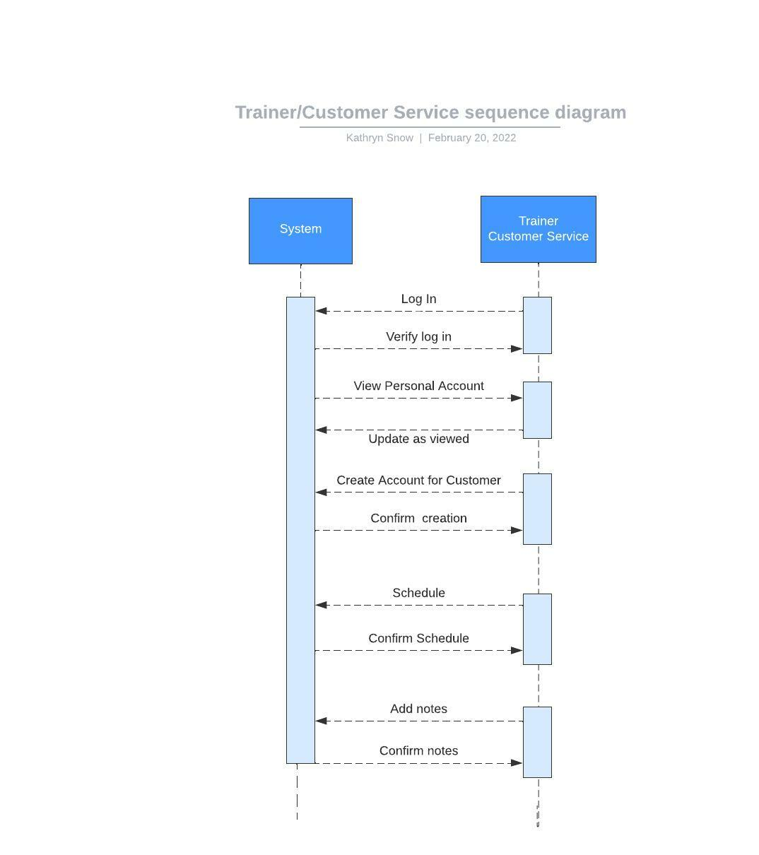

### UML Class Diagram

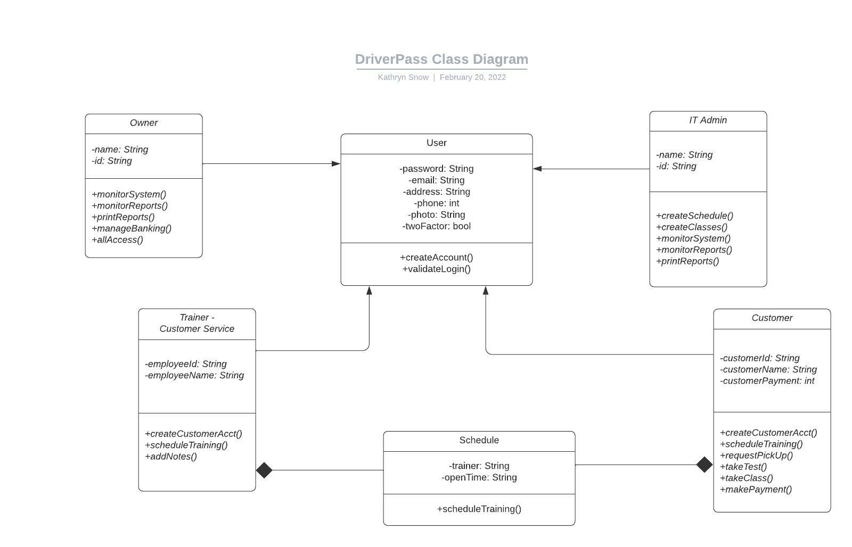

## Technical Requirements

* Authentication and Authorization
  + Access to data will be validated and authorized as shown in two-step authentication.
* Internal Controls
  + Access to data will be limited to role of user as shown in the use case diagram.
* Data Quality
  + Data quality will be high in the classes, tests, and input into our schedule and personal accounts by limiting character types allowed.
* Maintainability
  + The system will identify and resolve technical problems in a set timeframe. Repairs need to resolve in one hour.
* Serviceability
  + Nightly updates and the occasional upgrades will not shut the system down.
* Performance
  + We have set a performance requirement for load times to exceed only two seconds.
* Productivity
  + Users will find auto generated data to skip inputting data multiple times.
* Interoperability
  + The software offers comprehensive compatibility. This means it will work on all major operating systems, web browsers, and technical devices.

I.E.T. (2022, February 10). *Technical Requirements (With Definition and List of Examples)*. Indeed Career Guide. Retrieved February 20, 2022, from https://www.indeed.com/career-advice/finding-a-job/technical-requirements